**The Middle Edit: What Happens Between the First Draft and Line Edits**

with Karen Albright Lin

CO Cold 2024

What is the big picture story in your current project?______

Are there scenes that don’t directly affect that story? List them_____

Can you remove these scenes without disrupting the story?_____

What does the story lose by excluding these sceses? __________

What might your story gain? _____

Does it leave pot holes you’ll need to deal with?___________

Make a plan to revise if necessary ______________

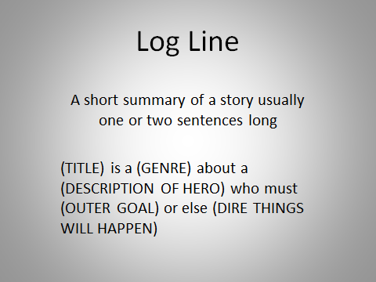

**Iowa Workshop Instructor Studied   
First 2 Pages of Bestsellers**

Sentence with 3 commas • a 1 word sentence • alliteration • food (universal ritual) • body fluid🡪sweat/blood/tears/ urine • reference to sex or death • something sinful or painful • a color • a personality trait • question mark • mention of nature • a brand name • furniture • body part or parts • smell or odor • metaphor (each saving 5 pages of description) • city, state or street • walk/gesture/overbite/musculature

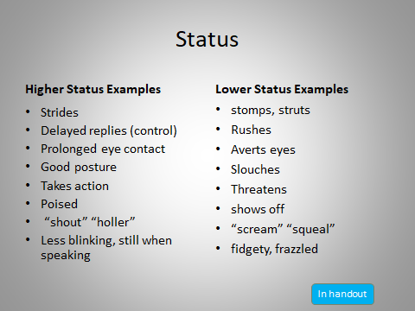

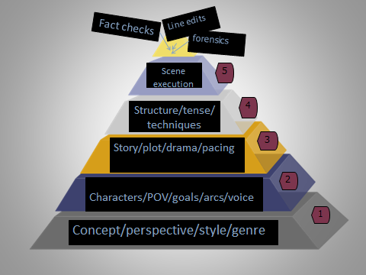

**Successful Voice Asserts Itself**

* Adds style, energy, urgency
* Fresh, readable
* Enhances without distracting
* Engaging, exciting, risky
* Appropriate emotions
* Confident if breaking “rules”
* Patterns, habits and language

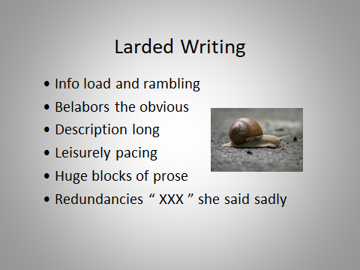

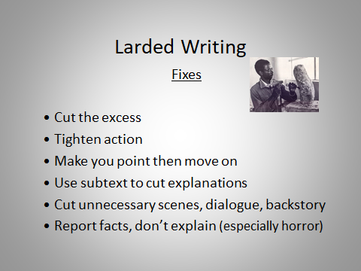

**Fiction Genres Word Counts**[**Mainstream Romance: 70,000–100,000   
Science Fiction / Fantasy: 90,000–120,000   
Thrillers / Horror / Mysteries /and Crime: 70,000–90,000   
Historical Fiction: 80,000–100,000  
Young Adult: 50,000–80,000   
Middle Grade: 25,000–40,000  
Flash Fiction: 300–1500   
Novellas: 30,000–50,000**](https://self-publishingschool.com/how-to-write-romance-sex-scenes/?channel=Organic&medium=Google%20-%20Search)

Genre conventions/tropes

Sci-fi and Fantasies have:

**A System**

Serves story

Makes sense

Rules don’t change

Believable in the story

Magical for the reader

Romance vs. Romantic Comedy

Rom-com is ridiculous, but delightful

Romance of all types beware: simple/petty misunderstandings, one-sided or circular conflicts, low stakes, characters we don’t like, no sexual tension, often physically separated, out of balance (pushy/passive, strong/weak)

History

Truth Perspective

(What occurred) (what people believe)

Psychological Thrillers & Horror

Crime/victim(s)/protagonist mistakes/clues/red herrings/MacGuffin(what starts plot)/shape shifter/ticking clock/lives at stake/false ending

To avoid cliché’s, try do something puzzling 🡪 break rigid rules (ex Mysteries 🡪 *Columbo*, *Monk, House*)

Requirements/promises of genre (PofG) (what they all need, tropes and conventions each needs)

specific feelings/emotions, authenticity, know their highs and lows

Genre:

**Romance** offers a satisfying and successful end

**sci-fi** hero’s journey p 45🡪 WD 9/21

(trick to making readers believe, ironically, is to have a character question that believability. Ex: someone in the story says or thinks, “There aren’t any fairies” or “Witchcraft doesn’t work.” Now reader doesn’t have to question the fantasy, allows her to buy in and feel one up on the characters). {layered world-building

**Fantasy** (subgenres like Steampunk, Gothic, and magic Realism) [layered world-building, culture and even the smallest of details like the fabric of clothing]

**Sci-fi and fantasy** structure depends on what’s important

* milieu (*Gulliver’s Travels and Wizard of Oz* – start at home or on arrival🡪end back home)
* Idea story (process of seeking info (2001: A Space Odyssey - starts with a question, ends when answered – How will humans be affected by AI?)
* transformation of character story – Luke from farm boy to Jedi Knight)
* event story (old order restored, new order, or chaos—*Armageddon*)

**Mystery** – whodunit and how (subgenres like cozies, police procedural, etc) (Beware: put grit or dark elements in a cozy 🡪 it likely won’t sell), violence occurs before story starts. Appeals to intellect. punish bad guy.

**Suspense**—Readers anticipate, impending crime needs to be averted, heart (worry)

Info on the subcategories of crime fiction pg 38 WD may/june 2020 (espionage, noir, paranormal, police procedural, suspense, thriller, traditional 🡪 categorized by criteria🡪 protagonist, pace, personality, people, place, process)

**Thriller** – how can we stop them from doing it. (subgenres like espionage), often educate.

**Psychological thriller** – engaging protagonist makes a series of bad decisions for the right reason

**Married genres**…Romantic suspense (romance comes firsts, that is front and center)

**A memoir** in a style of a detective novel (Suzanne Handler’s *The Secrets They Kept*)

Difference between **traditional mystery and thriller** (page 29 WD march 2023)

**Historical Novels** – two plots 1) what-really-happened plot and 2) the plot that comes from your imagination. History is just old gossip. Keep your character center stage and the research in the background (this will also help with the researching forever challenge), watch for anachronisms, facts right, accurate details. use concurrent events in politics, music, religion, science, edit, food, literature, art (and diaries/letters could help in plotting)

**Action/Adventure** – actions involve risks, danger, unexpected excitement and experiences. Pacing: break of actions with breathers. Avoid superfluous description

**Horror** leans into dark imagery, reader wants to work with you to be scared. The more real the characters’ response, the more frightening the threat. Should creep the hell out of the reader. How will character die? Often uses universal fears like monsters in the dark. Appeals to gut.

**Trope vs Archetypes** (clown terrorizing others vs demented clown is the archetype/trope)

**Literary** imposes far less pattern on stories, character-driven, about transitional passage, coming of age, overcoming abandonment, facing mortality, global themes like good vs evil or autonomy vs. interdependency

**creative nonfiction**: true stories told well, good ones read like novels

**nonfiction:** fills a gap, solves a problem, presents a new way of thinking

**Memoir** as “detective novel” [p 53 WD 9/21] Knopf editor Deborah Garrison said, “A novel that’s merely autobiographical is a great disappointment, but a memoir that reads like a novel is a great surprise.” (put in writing your life – and look her up)

**children’s:** different approaches, requires child contribute his own different memory, imagination and dreams. See from their perspective and needs.

**YA** – painful downs, gratifying ups

**Middle Grad** – small sphere (family/friends) challenges, stakes feel high because everything is new, trying to figure yourself out… beware: don’t talk down to or use stereotypes

**Adventure, spies, and thrillers** stakes should be as believable as possible

**Mixed genres** like Neil Gaiman’s American Gods (called mystery and magic)

* identify base genre and subgenres (not equal time)
* compare in a way that makes sense and focuses first on base genre (*The Time Machine* meets *Gone With the Wind*)

**Screenwriting** is another beast (almost always 3 ACT structure, everything pithy, all about the visuals – rarely Voice Over 🡪 *Forest Gump*)

trope subversion 🡪 *Warm Bodies, Pulp Fiction*

want to change genres? what’s my motivation? Do I like the new genre? Open or close doors? The genre of you

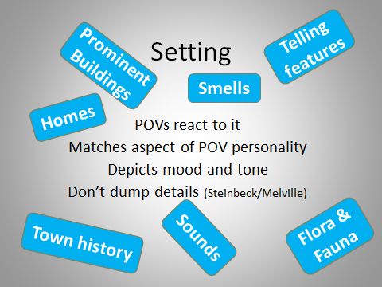

**Simple Log Line:**

My novel is about a ____ who ____ in order to____.

A desperate mother enters the world of Chinese mythology to free her six-year-old son from the spirit of a self-mutilating Chinese hunger striker who endangers him. – screenplay The Dark Side of Morning Light by Karen Albright Lin

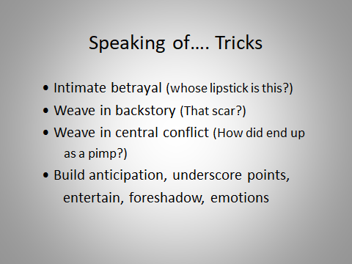

Distinct Dialogue

* Vocabulary appropriate for character
* Regionalisms
* Age
* Favorite words or expressions (don’t overdo)
* Syntax (English as second language)

“Please where bread is?”

* Dialect / “Ha ya luvin it? / phonetic spelling
* 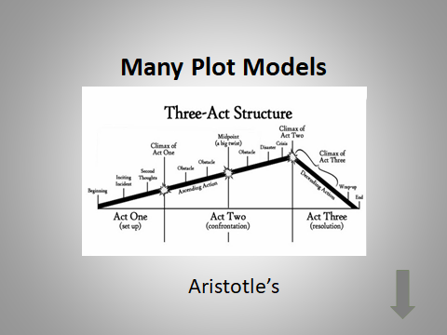

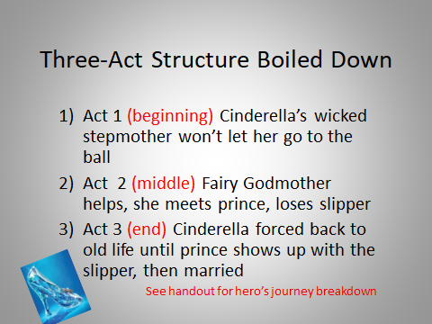

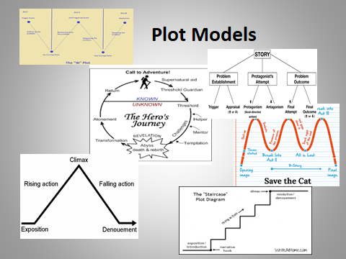

* **Storyline Consistency**
* **Forward Drive**  goals, plenty of obstacles, character changes gradually, pacing works, maximized opportunities for tension, dreaded middle sag
* **Point of View**

**Deep enough in POV?** drift in and out of omniscient? first person peripheral (like *The Great Gatsby*)? or third person? writing at arm’s length

* **Point of View Choice**

**Deep enough in POV?**

2nd person Choose Your Own Adventure” series

**Some common in certain genres. Examples:**

**Romance 2 viewpoints limited 3rd person**

**General fiction 1st person or a single 3rd person**

**If 2 POVs need 2 voices, 2 arcs**

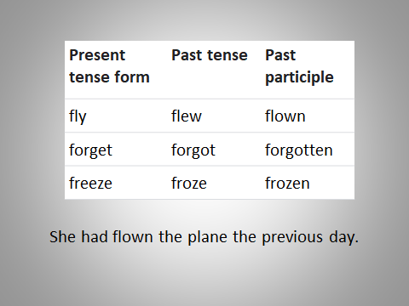

Characters

Different agendas

*Good Will Hunting* – Will would like to be invisible yet he’s solving difficult math problems on a blackboard at MIT…almost caught…still does it…so clearly wants to be noticed for his talents

Character Development

* Character stays consistent, true to her nature, not too good to be true or too bad to be true, isn’t cliché, different than other characters, make her fascinating, internal and external
* Goals? Occupation? Hobby? Fears caused by past traumas? How she handles money? Gifts?

Check character

* What does he *say* he wants?
* What does he *think* he wants
* What does he *really* want?
* What is his POV on his desires and the obstacles?
* Contrast sufficiently
* Relatable dream or desire
* In danger
* Rebel with a cause
* Competent at something

Trait that Hurts Her   
or is Deadly  
Same Trait that Saves the Day

Character Sympathy Test

Jeopardy?

Vulnerable?

Hardship?

Underdog?

Persistent?

Internally conflicted?

Old wounds?

In denial/overly optimistic/stubborn?

**Flaw?**

**hero flaws?**

- Is his own antagonist

- Basis for the story

- Forces hero to choose between her flaw and an opportunity

- Must be overcome to accomplish goal

- Flaw can become his strength

Take your beginning to the next level

- Consider beginning where the solution begins

- Place a seed of the resolution right up front

- Foreshadow so reader worries

- Hint that your protagonist has the stuff to take on the problem

“I liked Ben better when he wasn’t trying to kill me.”

Prologue

Perhaps chapter 1

Roots the events of story

Necessary as set-up & short

Purpose or throat clearing?

Different time/place/POV

Could bookend with epilogue

Flashbacks:

• Short

• Essential to advance story

• Triggered/sensory/thoughts

• No dump/interrupts flow

• Transition using tense change

**5 Types of endings**

* Happy, lead gains objective
* Unhappy, lead loses objective
* Lead gains objective but loses something more valuable (classic tragedy/*Titanic*)
* Lead sacrifices objective for greater good
* Ambiguous or bittersweet (often literary)

Can Use Software

Like Scrivener – $59.99

organizing and outlining and storyboarding

(be prepared for a learning curve)

One Index Card Per Scene

Setting & what makes you read on…

Action? Peril? Chase? Jeopardy? Portent? Decision? Prediction? Moment of Decision?

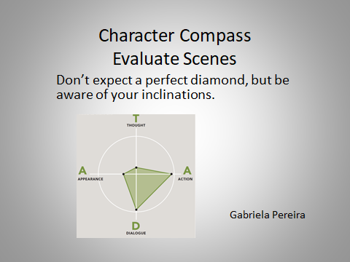

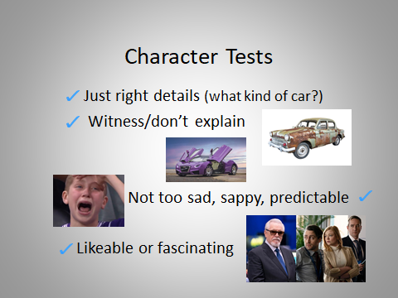

Character Tests:

What they want

What they think they want

What they subconsciously want

Evolving goals

Dueling desires

Symbol defining her

Flaw could save the day

Greatest need always present

Unable to walk away from danger

Something hidden

Specific

Consistent

Complex

Contrast

Originality

Authentic

Voice

**Scenes  
Change Up Beginnings**

Open with viewpoint character

Dialogue, thoughts, descriptions

(put it close to the hot spot)

Objective (explicit looking for him

or implicit (scanning the room)

Refining characters

* Tension between/within characters?
* Enough introspection so readers understand motivations? Too much?

**Rewrite Confusing Sentences**

What was ahead of him, what was causing terror, was something dark and unseen. In the hovering over visions.

would be better:

He sought the source of nightmare fear.

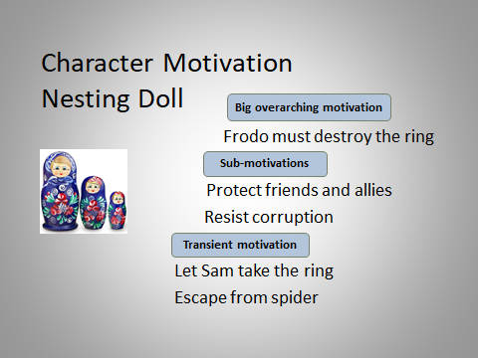

**Kill your babies**

poignant lines, brilliant subplots,

amazing scenes, etc. that aren’t necessary

clues you have one

🡪 you’re in love with it

🡪doesn’t fit with the rest of the work.

If killing them hurts too much, create a file for them and shove them in there.

**What’s the middle muddle?**

Too long and slow

Some not integral to story

Nothing to root for

Contrived or predictable

Not enough happening

Problem not extreme

Pacing too fast or slow

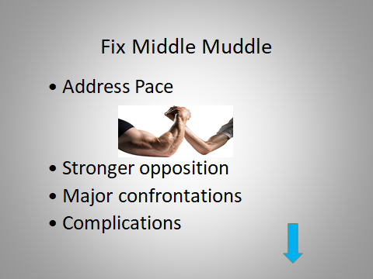

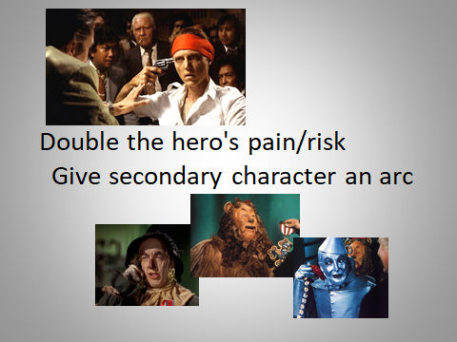

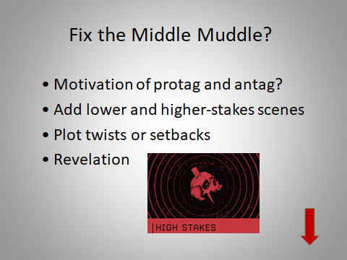

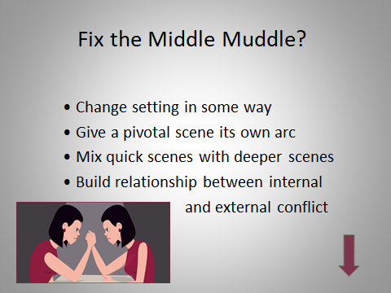

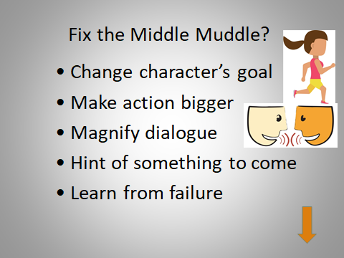

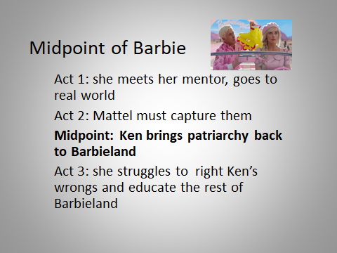

Pace – increase speed

Change  
Less punctuation  
Summery (one week later)  
Punchy verbs, active voice  
Emotionally charge scenes  
Shorter chapters, scenes, parag  
Combine scenes (argue in the car to school)

Pace – decrease

Description  
Distractions  
Exposition  
Sequels  
Emphasize moment  
Less passionate or emotional impact  
Small actions like gardening

If the ending feels flat, try

1. try alternate outcomes
2. reevaluate what your protagonist wants to accomplish
3. raise the character’s stakes
4. Be sure your theme is buried in there
5. did the character set her sights too low?
6. is the “perfect” outcome not practical
7. does the solution create a greater good
8. save some plot for the end
9. in denouement some last payoff or conjecture
10. dispose toxic crud, embrace life and love
11. break apart or pull together characters
12. encounter scene or feeling from the beginning (place or mood)
13. showdown – face the truth one last time
14. inject more emotion
15. be sure promise from beginning is fulfilled
16. add fallout
17. consider an extended denoument
18. stroke of hope, warm reader’s heart

One trick to tie up loose ends. Tie subplots in the reverse order of their introduction.

end by circling back to beginning scene (ex: *Pulp Fiction* with glow in the brief case) (ex: Rosebud in *Citizen Kane*)

Ending warnings:

• Not neutral

• No new skills/faults

• No new plot points

• Ilogical

• Deus ex machina a medical technician

• No emotional payoff

• No new characters (Bone Collector)

dialogue

women more likely to:

Talk more about feelings

Notice body language/facial expressions

Indirect/sometimes manipulative

Focus on building relationships

Sympathize rather than advise

Seek to create consensus

Use euphemisms

Hesitant to express anger

Ask more questions

Men are more likely to:

Talk about things or actions  
Short bursts & clipped sentences

Request specific information

Avoid difficult subjects

Focus on solving problems

Rarely say, “I don’t know.”

Want to make decisions

Avoid explaining

Seek to maintain status

Helpful tricks

• **Change your font and/or font color**

• Text to voice

• Enlarge display

• Focus on page visual

flow-how will readers’ eyes travel?

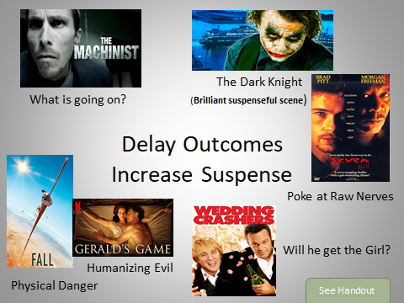

Subtext:

• Less is more

• Unstated goals

• What’s implied

• Read between the lines

•Tell one thing 🡪 show another

Less superficial

Engages more deeply

True intention

Deeper meaning

Plot, character, and dialogue

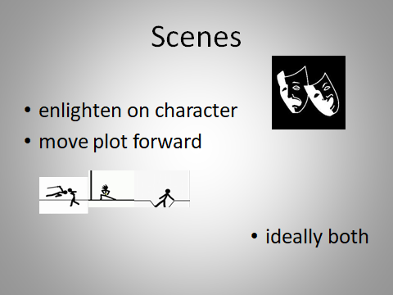

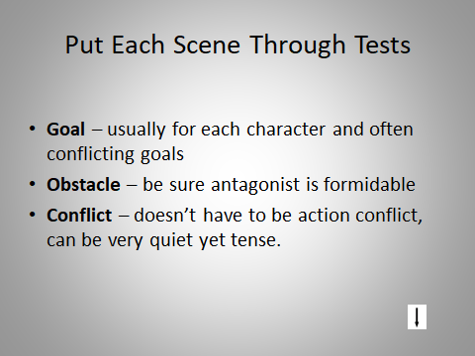

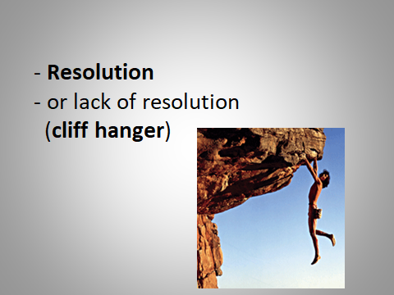

Pacing check list:

- Mix of sentence lengths

- Reveal time passing

- Sequels after emotionally charged scenes

- Push story ahead

- No unnecessary transitions

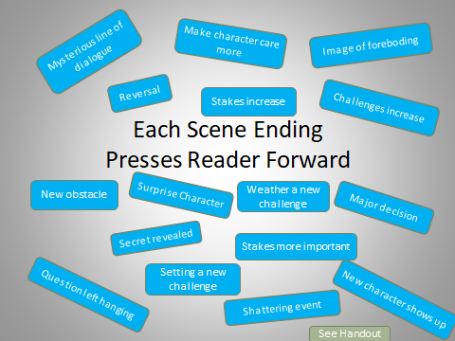

Scene fixes:

Hook?

Purpose?

Opposition?

A change

Rich subtext

Beginning, Middle, End

Flashbacks 🡪 straight chronology?

Can two characters be combined?

Warring goals 🡪 two ridged beliefs

Intro hero with one great scene

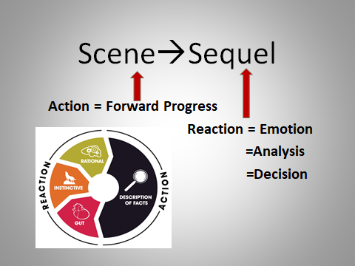

Where to stop a scene?

Major decision about to be made

• Warning of something bad to come

• Raising question with no answer

• Just as terrible thing happens

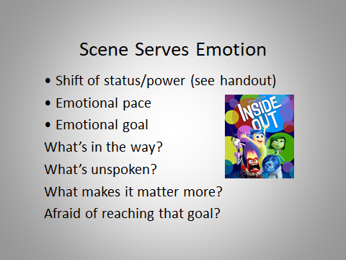

Fun tricks to cut words:

- Cut a random sentence. Maybe the third sentence in every paragraph on that page. Then reread and edit

(sometimes you don’t miss the sentence or it can be replaced by a single word or short phrase)

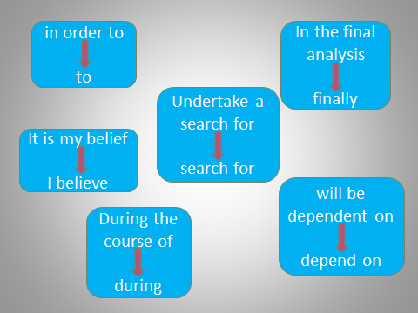

Grammar

common confusions

Ex: The woman who hid behind the cart spoke.

Ex: The woman that hid behind the cart spoke.

Ex: The horse that carried us over the mountain

has died.

Ex: The cavers found the cave that hid the gold.

**references & tools:**

recommended Books:

*Writing the Breakout Novel* (and workbook) by Donald Maass

*Gold, Motivation & Conflict: The Building Blocks of Good Fiction* by Debra Dixon

*Scene & Structure* by Jack Bickham

online:

Grammarly free AI powered citation generator (https://www.grammarly.com/citations)

Chat GPT

Character profile worksheet by Laura Hayden: <https://suspense.net/profile.htm>

Need ideas for next book? <https://www.plot-generator.org.uk/>

© Karen Albright Lin

<http://www.karenalbrightlin.com>

Author of:

<https://www.amazon.com/Shu-Mac-Cheese-Karen-Albright-ebook/dp/B08GGDQBLP>

 

<https://www.amazon.com/American-Moon-Chinese-Immigrant-Story-ebook/dp/B08B4FPN7Q>

karenalbrightlin.com

[writerslaunchpad@gmail.com](mailto:writerslaunchpad@gmail.com)

karenalin@comcast.net