**THE ART OF SHOWING EMOTIONS**

Peggy Waide, RMFW Colorado Gold

Much of our perspective is colored by our emotions. You need to convey not just what happens (**the action**), but also how this affects your characters and how they feel about the events (**the reaction**). Why? Because that is what your reader is going to connect with. Without the emotion, it’s easy for the reader to put down the book.

**THE STARTING POINT**

The showing vrs the telling of emotions:

Review an emotions wheel:

Emotions range in intensity – how does that impact your writing. Look at Anger, Fear, Love, Sadness and Joy. For example:

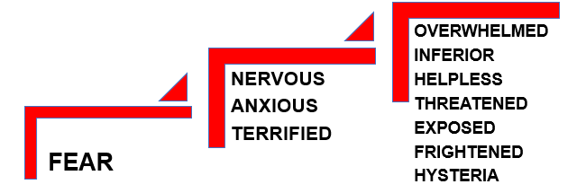 

**HOW TO WRITE WITH EMOTION**

**BODY LANGUAGE, FACIAL EXPRESSIONS, VOCALS (Examples)**

F.A.S.

**PLAYTIME**

|  |  |  |
| --- | --- | --- |
| **BODY LANGUAGE (Internal and External)** | **FACIAL EXPRESSIONS** | **VOCALS** |
| Tears fell  Vomited  Wretched  Turned away  Spun round  Sweat beaded  Cheeks flushed  Jumped backward  Crept on tiptoes  Clutched her chest  Twisted her hands  Stomped her feet  Smashed the wall  Lump in your throat  Churning stomach  Dry mouth  Shortness of breath  Clenched fists  Bite their nails  Rubbed her arms  Rubbed back of the neck  Swallowed deeply  Tugged earlobe  Blinked rapidly  Eyes flashed  Flinched  Pinched lips  Shoulders slumped  Drumming fingers  Tapping a foot  Pump fist in air  Chin held high  Heart raced  Pulse accelerated  Stomach clenched  Blood froze  Head exploded  Heart warmed  Stomach fluttered  Chest tightened  Puffed out chest  Legs trembled  Goosebumps  Nostrils flared  Cocked his chin  Nibbled on one’s lips  Exhaled noisily  Body flushed red | Grin broadened  Wrinkled the nose  Smiling  Lip curled  Squinted  Mouth/jaw dropped  Brows lifted  Pursed lips  Sneered  Scowled  Eyes bulged  Squinted  Rolled one’s eyes  Eyes shifted  Facial tics  Eyes blinked rapidly  Winked  Eyes widened  Eyes narrowed  Frowned  Glared  Face drooped  Bared his teeth  Brows lowered  Brows lifted  Lips thinned  Teeth ground  Pouted  Pupils dilated  Lost all color | Wavered  Snarled  Smug  Disdain  Hostility  Gasped  Stammering  Stuttering  At the top of her voice  Barely above a whisper  Brimming with glee  Bubbling with enthusiasm  Could shatter glass  Honked like a foghorn  Cold with anger  As sweet as sugar  Under his breath  Sarcasm  Disapproval  Caution  Pleading  Melodic  Indifference  Desperation  Humor  Pleading  Soothing  Lyrical  Shrill  Feeble  Whispered  Stilted  Trembled  Rasped  Sullen  Whined |

|  |  |
| --- | --- |
| her heart leaped into her throat  his heart hammered in his chest  his heart pounded  his heart jumped  her heart lurched  she trembled inside  he suppressed a shiver  his legs trembled  sweat beaded her forehead  dread twisted in her gut  his stomach clenched  her belly cramped  he felt like he might throw up  ice chilled his veins  her body went cold  raw panic was in her voice  terror thundered down on him  fear caught her in its jaws  she ordered a drink to drown the panic  he arranged and re-arranged the items on his desk  a nameless dread engulfed him  fear clawed up her throat  terror sealed her throat  his throat tightened  color drained from her face  his face turned as white as her bleached t-shirt  she blanched  dread gnawed at his insides | the words were trapped in her throat  her voice was numb  his voice was shrill  her defiant words bounced off the walls  her body felt numb  his blood froze in his veins  adrenaline pumped through his body  adrenaline crashed through her  fear pulsed through him  her scalp prickled  the hairs on the back of her neck stood up  his mouth went dry  his bones turned to jelly  her bones turned to water  he didn’t dare to move  the scream lodged in her throat  his mouth was open in a silent scream  she cowered  she flinched  a bolt of panic hit her  his eyes went wild  he lay awake, his mind racing  his eyes widened with alarm  fear trickled down her spine  panic seized his brain  she felt a flash of terror  a chill washed over her skin |