The 5 Sentence Method

Colorado Gold Writers Conference

Presented by Rebecca Thorne

The 5 Sentence Method is a method between plotting and pantsing, designed to offer a comprehensive understanding on plot structure without sacrificing spur-of-the-moment creativity.

Inspiration for this method is pulled from craft books like *Save the Cat, My Story Can Beat Up Your Story, The First 50 Pages, Wired for Story,* and many others. I also recommend checking out the *Snowflake Method*, which is a website that breaks down story structure in a similar manner.

This method is based around the 3 Act Structure:

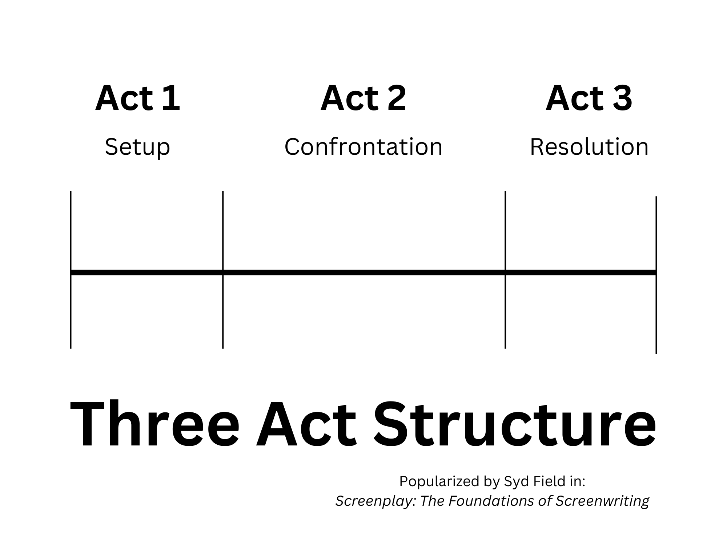

However, this structure is limiting in its ambiguity—it doesn’t offer concrete pacing points, which means a plot using this structure might be tricky to follow or require extensive edits.

As such, I’ll break down the 3 Act Structure into five specific sentences.

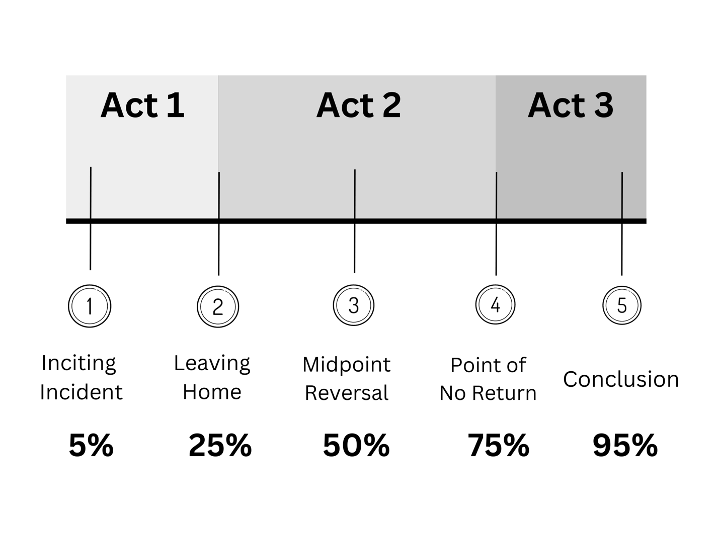

Let’s break these sentences down:

1. **Inciting Incident:** The moment where your character is facing a break from “normal,” and they choose (or are forced) to deviate from what they’ve always known.
2. **Leaving Home:** The beginning of the journey, the proverbial “leaving the shire” moment. This usually involves a resolution to the inciting incident, and begins either a physical or *metaphorical* shift in the character’s present situation.
3. **Midpoint Reversal:** The moment where everything your character thoughtthey knew changes… often very dramatically.
4. **Point of No Return:** The character pushes into a moment of certainty, where the events that follow cannot be stopped. It’s the moment a snowball becomes an avalanche that carries us to the end of the novel.
5. **Conclusion:** The moment where everything wraps up. Villain is defeated, character is either successful or not.

These plot points become your five sentences. As you’ve noticed, I’ve attached them to specific **percentage points** throughout the novel. We’ll use those percentages to correlate with your word count goal, which will ensure that your pacing is always on point!!

First, determine if you are an **overwriter** or **underwriter**.

* **Overwriter**: Writes long novels and cuts the wordcount in edits.
* **Underwriter**: Writes short novels and adds in edits.

Then, use your word count estimates for your genre to determine an appropriate end-goal word count.

* **Middle Grade**: 40,000 – 60,000 words
* **Young Adult (contemporary)**: 60,000 – 90,000 words
* **Young Adult (SFF)**: 75,000 – 110,000 words
* **Commercial / Literary**: 70,000 – 110,000 words
* **Romance**: 50,000 – 100,000 words
* **Mystery**: 80,000 – 110,000 words
* **Historical**: 75,000 – 110,000 words
* **Fantasy / Science Fiction**: 80,000 – 130,000 words

Estimate how many words you cut (overwriting) or add (underwriting) in your editing stage. Use that number, plus the word counts above, to calculate your word count goal for your first draft.

**Overwriting Equation:** FIRST DRAFT GOAL – WORDS CUT IN EDITS = FINAL WORD COUNT

**Underwriting Equation:** FIRST DRAFT GOAL + WORDS ADDED IN EDITS = FINAL WORD COUNT

EXAMPLE:

Let’s say a writer is attempting a 100,000 word Adult Fantasy novel. She is an **underwriter**, and expects to **add 25,000 words** in edits.

That means her first draft will be approximately 75,000 words.

Which means each of her 5 sentences correlate to the word counts below:

1. Sentence 1: 5%, 3,750 words
2. Sentence 2: 25%, 18,750 words
3. Sentence 3: 50%, 37,500 words
4. Sentence 4: 75%, 56,250 words
5. Sentence 5: 95%, 71,250 words

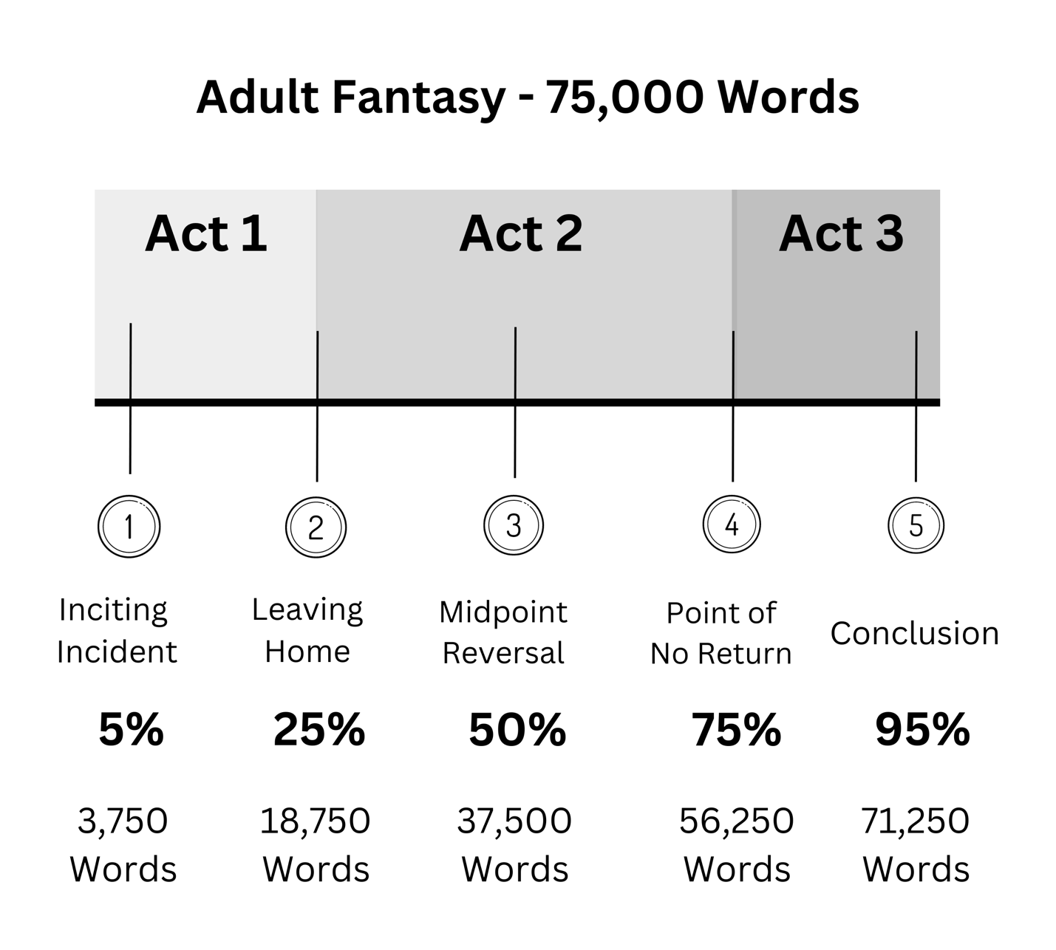

By using this method to track your plot progression, you can easily see when you’re writing too much—or too little—per section. So, if this writer’s Leaving Home moment happens at 24,000 words instead of 18,750, readers will say her beginning “was slow” or “lagged.”

This allows writers to anticipate pacing issues before publication, and adjust their plot progression to accommodate.

Let’s explore some examples on the next page!

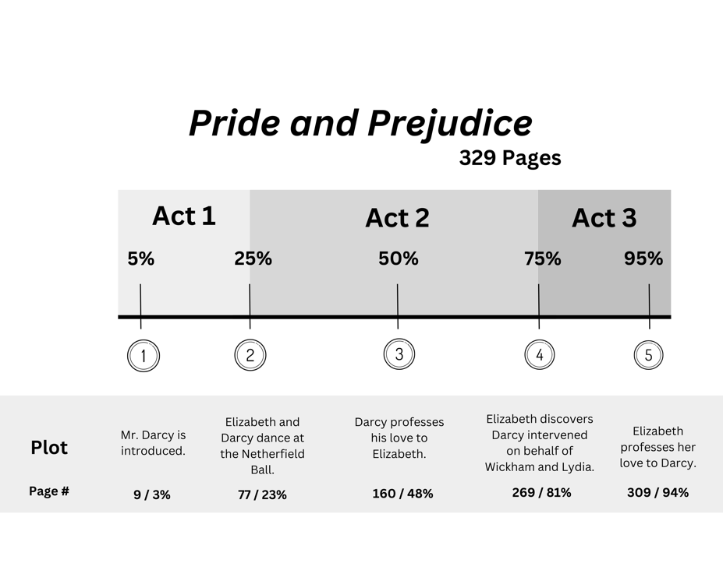Pride and Prejudice is a great example of a typical plot structure. The love story IS the plot here, which means every beat relates to Elizabeth’s and Darcy’s relationship.

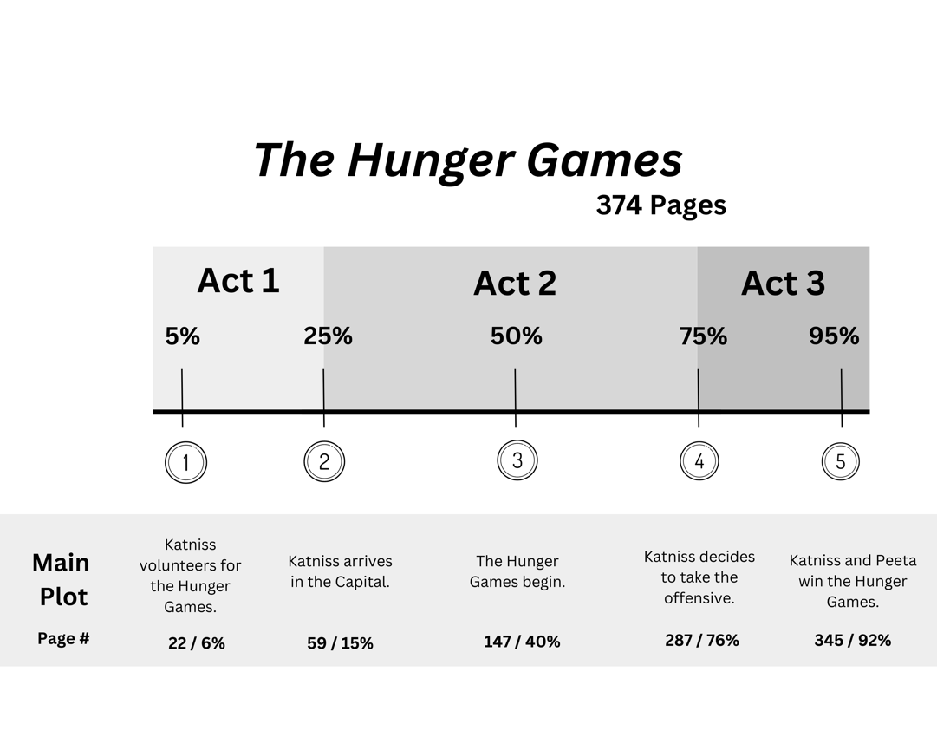**Typically, plots will have TWO focuses: the external, physical plot, and the internal, emotional one.** However, romance stories often bundle those into the same plot points.

The Hunger Games is an example of structuring a trilogy. We’d expect the Hunger Games to begin at the 25% mark, but Collins pushes that until the Midpoint Reversal. This is because it was a planned trilogy, which means **she *had* to spend more time in the Capital**, showing us how terrible they are. Otherwise, the war we see in books 2 and 3 wouldn’t make sense.

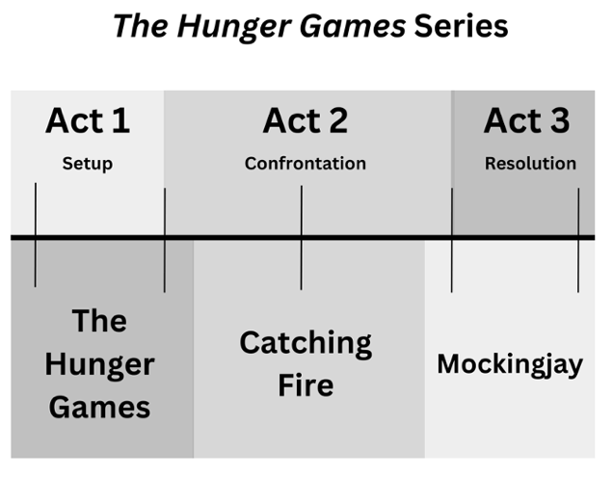 Here, you can get a rough estimate of how a trilogy might be laid out over the 3 act structure, where each book follows roughly one act. (Act 2 is always the longest, hence why it spills into books 1 and 3.)

Let’s look at some examples where an internal and external plot work in tandem with each other.

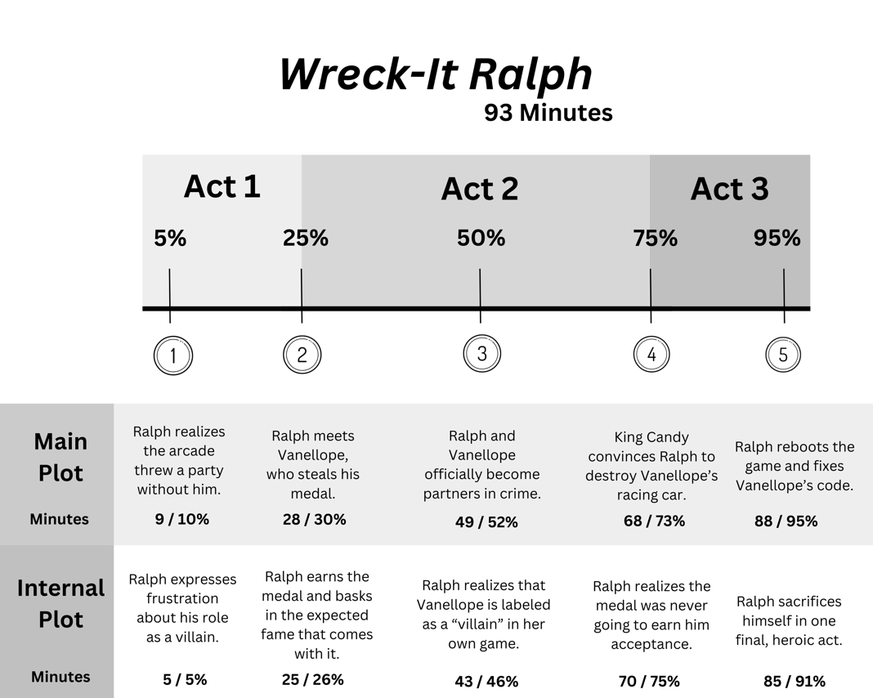

*Wreck-It Ralph* is one of the best examples of plot structure I’ve ever seen. The main plot hits every beat, almost exactly where it’s expected, and Ralph’s internal journey follows a similar path.

The main plot focuses on Ralph attempting to steal a medal to be seen as a “hero.”

The internal plot identifies what it *means* to be a hero, and how external judgement or a forced identity doesn’t change who someone is on the inside.

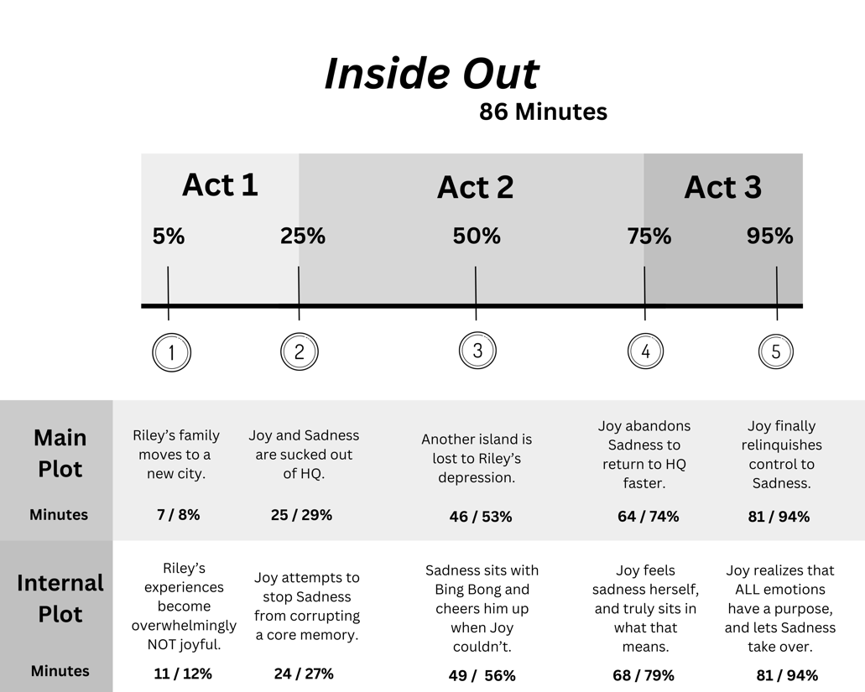

*Inside Out* is another great plot example—but since the point of this movie is to examine *emotions*, Joy is the main character. Riley is important, but she’s arguably more of a vehicle for Joy’s story.

The main plot, therefore, has external influences through Riley’s eyes. It focuses on external events that impact internal issues: the move to SFO, and how it affects Riley—and thus, her emotions.

The internal plot is Joy-focused, centering on how she attempts to reclaim control even to Riley’s detriment.

An example of a bad plot is always helpful, too! When you don’t have a concentrated idea of your main plot and internal plot, and how they might progress, you’ll run into plot issues that disrupt reader enjoyment.

*Onward* is our example of that:

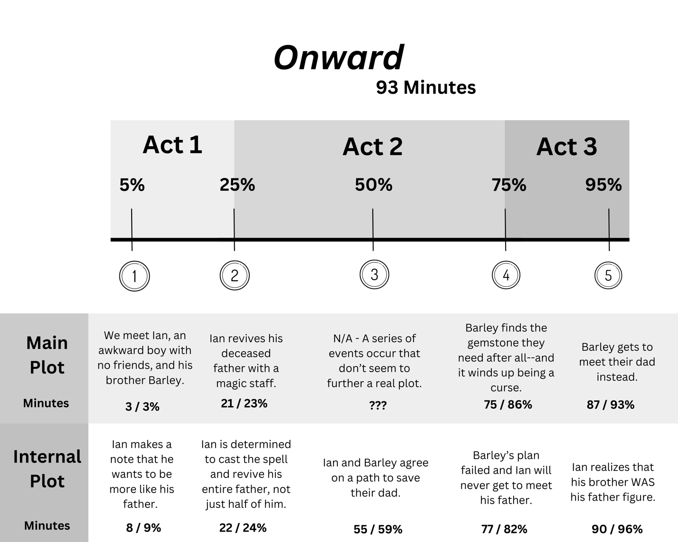

The plot tried to go in too many directions, and we got confused in the end. In my opinion, this movie couldn’t decide on a main character—and since they’re both following their own plots, it got complicated quickly. Ian was supposed to be our main character, but he was constantly wrestling with his brother Barley for the spotlight.

Always make sure you understand your main character’s motivations, and ensure they’re cool enough to *be* your main character. *Onward* could have been a better movie if it followed Barley only, but since Ian was our de-facto main character, we got this half-hearted mess instead.

If you’d like more information on the 5 Sentence Method, you can purchase my craft book on Amazon: <https://www.amazon.com/Sentence-Method-Write-Your-Already-ebook/dp/B0CQLG37LG>