How Not To Explain Your WIP
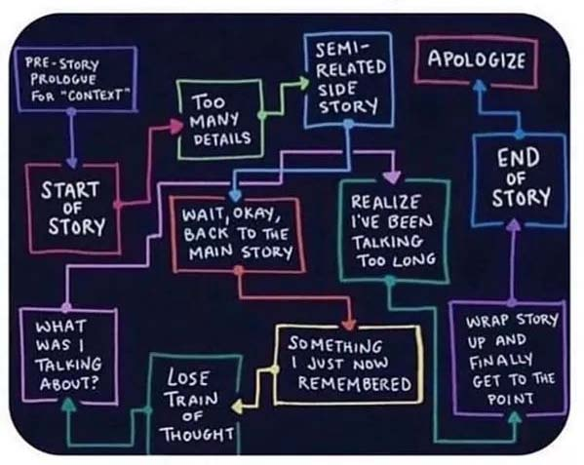
Pitch #1 = Networking – do this from the day you start your manuscript or decide you’re going to be a writer

A two sentence blurb; memorize so you can rattle it off without stumbling or sounding like you’re a robot, PRACTICE it regularly – not just once and done
Examples:
- I’m traditionally and self-published in historical romance, and am currently writing a mystery. No matter what I write, it always has romance, mystery, and a little bit of history, in one order or the other.
- If they ask more questions, I say: I’m working on a mystery series with a female classic car restorer who “reads” the history of the cars when she touches them – the car’s past includes a mystery she has to solve, along with a contemporary mystery that may or may not be related but threatens her, or someone/thing she loves

Pitch #2 = Manuscript/Your Pitch Appointment

A 2-3 sentence description of your book. Yes, 2-3 sentence! If you can’t give the gist of the story in 2-3 sentences, you need to try harder.
3 Examples:
- A female classic car restorer has the ability to “read” her projects, and the stories they tell reveal past crimes, forcing her to find current solutions, or die trying.
- Renni Delacroix is unique in her field of classic car restoration, not only because she’s female, but because she harbors a psychic connection to cars. When her newest project reveals a link to a serial killer, she must discover the identity of the killer - a man closer to her than anyone realizes.
- A female classic car restorer discovers her newest project belonged to a serial killer; if she doesn't discover his identity, he'll add her, and others she loves, to his growing list of victims.

Fiction Genres/subgenres
- SOME genres and sub-genres – there are many more, and some go by multiple ames. It’s always easiest if your story fits cleanly in a genre or common sub-genre
  - Most Common Genres
- Romance (more than 50% of fiction books sold are romance, so quit making snarky comments about romance writers!) Romancing the Stone
- Action/Adventure (Lost World)
- Speculative (could include Science Fiction, Horror, Fantasy, Paranormal, Magic Realism or each of these can be a genre) Steven King
- Young Adult (generally main character is 12-18, but your readers might be older or younger than that) Harry Potter
- New Adult (one step up from YA) The Maze Runner
- Middle Grade/Picture Book (Grade School and younger)
- Mystery/Crime/Suspense/Thriller (Jack Reacher)
- Historical (may be a sub-category for other genre, i.e. romance, mystery, etc.) Pillars of the Earth
- Western (Lonesome Dove)
- Family Saga (Roots)
- Women’s Fiction (harder to define, but generally contemporary, plots that revolve around a woman’s relationships/conflicts, etc.) This is Not How It Ends
- Literary Fiction (focuses on the human condition, inner lives, theme, plot) To Kill A Mockingbird
Sub-Genres
    - Techno/Psychological Thriller (Michael Crichton/Tom Clancy)
    - Historical Romance (Unsinkable Love)
    - Police Procedurals (Michael Connolly/James Patterson)
    - Cozy/Amateur Detective (Agatha Christie/Lillian Jackson Braun)
    - Sweet/Inspirational/Christian (can apply to many genres) – generally faith based (no on-page sex or swearing) The Fault In Our Stars
    - Regency era (Jane Eyre)
    - Erotica (Fifty Shades)
    - Noir (Raymond Chandler)
    - Military (Band of Brothers)
    - Forensic (Patricia Cornwell)
    - Steampunk (lots of them – The Time Machine)
    - Space Opera (Ian M. Banks)

BOOK LENGTH
Book lengths vary by genre. Easy to Google your genre’s word count. Answers will vary, but you’ll get an average. DO NOT THINK that because you feel your book is amazing, agents/editors will overlook it if your genre average is 90,000, and your book is 102,000. They will assume you aren’t experienced enough to edit out the chaff. Most won’t take the time to even read it, let alone want to deal with that much editing. New authors should try for the lower range on the book or at least not exceed it.
- If you can’t find any words to cut, then you probably need to have an editor look at it (and this will probably cost you money – save as much money as you can by learning to self-edit well)
- Search “filler words.” Make a list, then search your manuscript. Take out the word and see if it materially changes the sentence (i.e. That, Just, Well, Oh, many of the words ending in –ly, can be taken out).
- Don’t keep repeating your character names, especially in dialogue. Cut, cut, cut. Then cut some more. If only 1-2 characters in the scene, no need for names except if it’s long enough to let your reader get confused otherwise.
- Romance MUST have Happily Ever After or Happily For Now, if not, it’s not Romance no matter what you think – this is one of the HARD AND FAST RULES
- Thrillers usually use a much faster pace, and focus less on details than some other genres so if you find yourself describing the plants and animals, clothes people are wearing, physical details, or long external or internal dialogues in a thriller, chances are you’ll need to cut some of that to keep your pacing up.

Recommended Books on How to Write
- “On Writing” by Stephen King
- The series of writing thesaurus’ by Angela Ackerman and Becca Puglisi (and their blog)
- Writer’s Market (expensive – reference section of library)
- Elements of Style/Strunk & White
- Writer’s Digest and website
- Chicago Manual of Style
- Conan the Grammarian
- The Writer’s Toolbox
- The Writer’s Journey
- Save the Cat!
Blogs & Websites
Preditors & Editors (spelling is correct) Career Authors
Kristen Lamb’s blog Query Shark
Nelson Literary Agency/Pub Rants Evil Editor
Agent Query Writers Helping Writers
Terrible Minds Writers in the Storm
Writing Forward Blood Red Pencil
Grammar Girl Thesaurus.com
Blog.reedsy.com/Worldbuilding Guide Dictionary.com & Merriam-Webster
Plot & Structure: Techniques and Exercises Book Architecture
for Crafting a Plot that Grips Readers from
Start to Finish Rocky Mountain Fiction Writers

Some Writing Groups
- Sisters in Crime
- Mystery Writers of America and Rocky Mountain Mystery Writers
- Society of Children’s Book Writers & Illustrators (SCBWI)
- Science Fiction & Fantasy Writers of America
- Western Writers of America
- Horror Writers Association
- Passionate Ink/special interest chapter of RWA for Erotic writers
- RWA (Romance Writers of America)
- SFWA Middle Grade and Young Adult Writers
Get the picture? There are groups for all types of writing
Copyright articles
- https://www.copyright.gov/circs/circ01.pdf
- https://fairuse.stanford.edu/2002/03/11/basic-copyright-principles/
- https://en.wikipedia.org/wiki/Copyright
- https://copyrightalliance.org/news-events/copyright-news-newsletters/copyright-small-claims/
- https://www.nytimes.com/2019/04/24/books/nora-roberts-plagiarism.html
Submitting, queries, synopsis, etc.
- https://www.publishersmarketplace.com/ (paid)
- https://agentquery.com/publishing_mp.aspx
- http://www.writersmarket.com/ (paid or library)

Some “Filler Words” to watch out for
That Just Only Really Slightly Almost Seem(ed)
Perhaps Maybe Simply Somehow Absolutely Basically Actually
Now Sort of Kind of A little Very So Some
Like Think Feel/Felt Then Back Turn Look
Walk All Sudden(ly) Literally Quite In order Rather
Stuff A little/bit/lot
Sit down/Stand up - just sat or stood
Nodded his head (can’t nod anything else)
- In general, be concise – don’t waste words you don’t need to
Words that can/should be more descriptive (there are a ton more/use a thesaurus*)
Look (peer, peek, eye, stare, ogle, survey, etc.)
Walk (saunter, prance, slide, plod, stumble, etc.)
Run (sprint, streak, hustle, jog, etc.)
Big (enormous, giant, large, expansive, etc.)
Little (miniscule, tiny, midget, etc.)
*don’t get carried away – sometimes run or look is just fine!

